Network Drive Cleanup & Optimization Best Practices

About: These standards were adapted from the Michigan Technological University and were shared by Ruth Archer, PHD, through the Continuous Improvement training in February 2021. This process is based on a LEAN technique called 5S (Sort, Shine, Set in Order, Standardize, & Sustain) and is part of the “Do” step in the PDCA cycle. This kaizen framework can be completed as an individual for personal drives or as a team for departmental drives.

Goal: To improve organization, standardization, and sustainability of our network drives while eliminating clutter, confusion, and waste.

Definitions:
Kaizen – a Japanese term meaning "change for the better" or "continuous improvement.”
Newspaper - A tool for visually managing continuous improvement suggestions. Based on the PDCA cycle and designed to manage input by the workforce in an organized way.

At the pre-meeting:
• Get drive properties: number of root items, GB of space, total number of files and total number of folders. (Repeat this process as necessary before and after each day of the kaizen event, as well as after the newspaper items for the kaizen have been completed).
• To find the total GB of space, number of files, and number of folders: Right click on the folder, and select “Properties.”
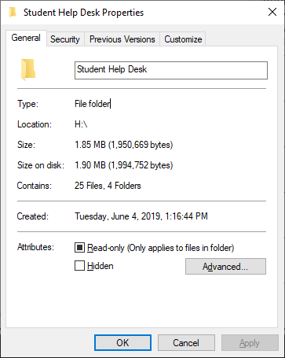
• Note: If the reason for the kaizen includes confusion on where to find files or if the above numbers are not “bad,” also consider a timed test, check numbers throughout, and repeat timed tests after the 5S of the drive is completed.

Between the pre-meeting and kaizen:
• Assign/do an initial sort before the first kaizen meeting as a group, getting rid of anything that is obviously trash or doesn’t require group discussion for sorting.
• Contact IT Services to get a list of the users who have access to the network drive – helpdesk@owu.edu.

At the kaizen event:
• Start out the event by defining the purpose of the drive! This can really help later on in the event to clarify where a file belongs or if it even should be on the drive.
• Determine the root menu items (folders) based upon the purpose of the drive, and do initial sorting as a team for files that are questionable as time allows.
• Determine naming, revision, and other standards as applicable to the specific drive and its purpose.
• Determine audit or other maintenance procedure for sustaining the improvement.
• Determine how record retention requirements may impact the kaizen event.
• Determine which users need and do not need access using the list provided by IT (e.g. if a user changes jobs to a different department or leaves the university, they no longer need access to the drive). Provide IT with the list of users to remove access from.

After the kaizen event:
• Complete the “sort,” “set in order,” and “shine” outside of the event.
• Create (and follow!) the standards document, audit, etc.
• Make sure all files and folders are “shined” to meet the standards (can be done while sorting).
• Get drive properties: number of root items, GB of space, total number of files and total number of folders after the kaizen event to measure your progress.
• Share the standards with anyone who accesses the drive!

Advice: Some network drives may be too large to accomplish everything in a single kaizen event. If you are struggling to make progress, start with a single subdirectory or data type. As your team becomes more comfortable with the process, you can begin additional kaizen events to complete the goals.

Kaizen Newspaper
 | Task/Idea/Improvement | Responsibility | Due | Status % | Notes
1
2
3
4
5
6
7
8
9
10
11
12
13
14
15
16
17
18
19
20
21
22
23
24
25
26
27
28
29
30
31
32
33
34
35

