Downloaded 11302025 from: Columbus Dispatch May 14, 2024
ENERGY-RESOURCE
AEP Ohio: Data center electricity demands to put central Ohio on same tier as Manhattan.
Mark Williams
Columbus Dispatch

ENERGY-RESOURCE
AEP Ohio: Data center electricity demands to put central Ohio on same tier as Manhattan.
Mark Williams
Columbus Dispatch
AEP Ohio is asking state regulators to sign off on a new plan to deal with the surge in data centers in central Ohio that is expected to eat up so much electricity in coming years that demand for power in the region will be similar to all of Manhattan.
The power company on Monday asked the Public Utilities Commission of Ohio to require data centers to make a 10-year commitment to pay for a minimum of 90% of the electricity they request, even if they use less.
AEP says the new rate structure would also apply to cryptocurrency mining operations.
"In order to protect AEP Ohio customers and future economic development in its service territory, the company wants to help ensure that any large-scale transmission investment is right-sized to serve load that will show up at the time it is committed to show up," AEP Ohio said in a filing with the PUCO.
"This approach should help mitigate any risks that the load may not show up at the level and time indicated or that facilities will be overbuilt to serve the actual load that develops."
Holiday shopping: We found the best Cyber Week deals for you.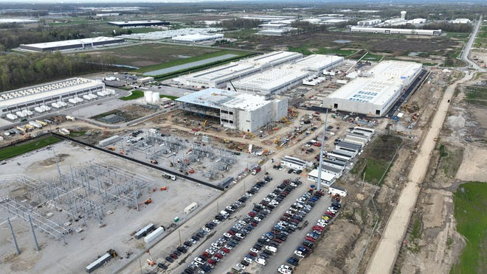
“Demand for computing power from data centers, which require enormous amounts of electricity, is being fueled by artificial intelligence and other new technologies. AEP Ohio is seeing unprecedented demand from data center customers, especially in the central Ohio area," Marc Reitter, AEP Ohio president and chief operating officer, said in a prepared release.
"While we see no concerns serving current or new residential and existing commercial or industrial customers, we need to ensure that the right long-term investments are made to the electric grid," Reitter said. "We need accurate plans and solid commitments from large data center customers so the right facilities are built at the right time. This will help us keep Ohio open for business for all industries, while making sure customers aren’t paying for unused infrastructure.”
AEP said adding large users will require investment in new extra-high voltage transmission lines needed to bring more power to the region. Those lines can take seven to 10 years to plan and construct.
Historically, AEP said load growth was expected to be 1%-2% year over year. Now the utility is forecasting average growth closer to 20% a year.
"AEP has signed agreements that will nearly double the amount of load served in Ohio in just over five years’ time," the company said in the filing.
"The development of new transmission facilities to serve a new, significant amount of load is dependent upon the customer’s commitment to bringing such large loads online. The amount of investment required to connect in the amount of load already signed is a fraction of the cost required to connect the next batch of large hyperscale loads waiting to connect to the network."
AEP's transmission system in central Ohio is serving about 600 megawatts of load − enough to power as many as 250,000 homes − from data centers. That's all come since 2017.
Since then Amazon, Google, Facebook and other companies have built data centers in the region. Amazon last summer announced a $7.8-billion expansion of its data service operations in central Ohio.
AEP has agreements for new demand from existing and additional customers to add 4,400 megawatts of power to central Ohio by 2030, making total demand for electricity in the region about equal to that of Manhattan, the company said.
The proposed rate commitment is meant to ensure that existing customers don't pay for the needed infrastructure to meet the demand from these new customers, especially if they don't ultimately connect to the system, the company said.
AEP Ohio, a unit of American Electric Power, provides electricity to 1.5 million customers.
mawilliams@dispatch.com
@BizMarkWilliams

