AYA & MA Field Placement/Student Teaching Application
Name

Email

Local address

Content area |  | Advisor
What high school did you graduate from? What district?

Cumulative GPA:____________
GPA in Content Area: ____________
GPA in Education Courses:____________
Have you been admitted to the Teacher Education Program?

_____Yes
_____ No (Please explain)

AYA candidates: Are you interested in a middle school placement?
_____Yes
_____ No
MA candidates: Are you interested in an elementary placement?
_____Yes
_____ No
Do you have your own transportation?  _____Yes  _____ No | If you have your own transportation, are you willing to take a peer to your school?  _____Yes  _____ No
Type of school: I am interested in learning in the following contexts (Mark all that apply)
_____ A public school
_____ A charter school
_____ A private school
_____ Urban
_____ Rural
_____ Suburban
_____ High-performing school
_____ High-needs school
_____ I don’t know which type of school I might be interested in
_____ I am interested in student teaching in Chicago
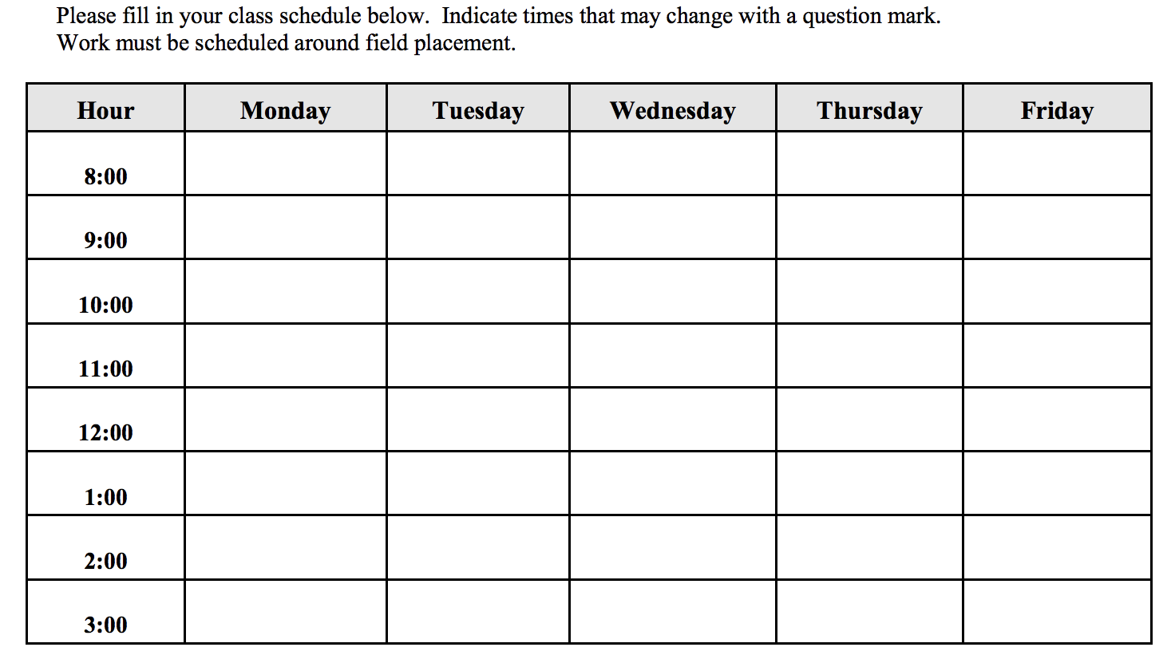
Is there anything else you would like me to know that is relevant to, and would help me place you in, your field experience placements?

