# **image001http://graphics.owu.edu/images/stacked/stacked_red.jpgController’s Office Procurement Card**

|  |
| --- |
| **OWU Cash Reimbursement Policy and Procedure** |

1. **Policy**

Employees must request cash reimbursements through the online smartdata system. Procurement card clearing and cash reimbursements are both entered through the smartdata system. All University related expenses purchased with a University card or an out-of-pocket expense will all be in one location. This will allow employees to reconcile all outstanding University charges that need allocated in one place at the same time.

Please refer to the Travel and Expense policy on the Accounting webpage (accounting.owu.edu) for more information regarding reimbursable and non-reimbursable expenses.

1. **Procedure**

Navigate to the smartdata system (smartdata.jpmorgan.com) preferably with Internet Explorer or Firefox.

* Hover over Account Activity
* Select Add Cash Transaction

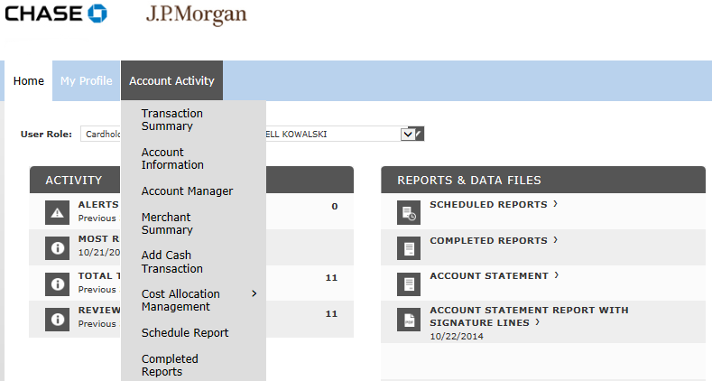

* Enter the Description (example: Mileage-Delaware to Cincinnati, Tolls, Subscription, Etc.)
* Leave the code as a Debit
* Enter the amount under “Original Currency Amount”
* Select the “Accounting Detail” Icon 
* Enter account numbers via the drop down boxes
* Select “Save”

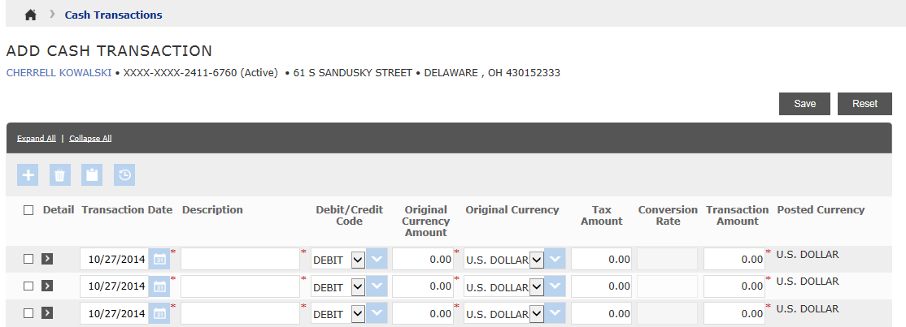

**Save**

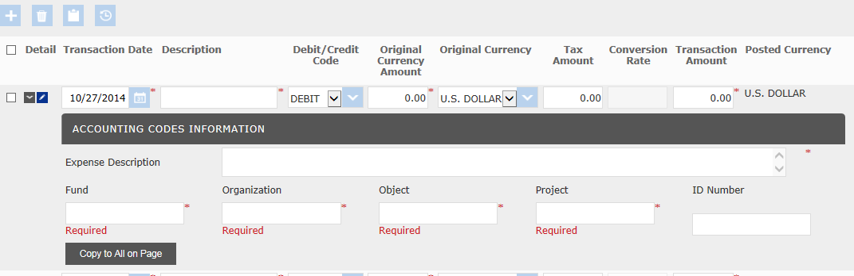

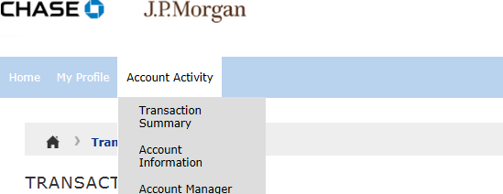

* Hover over “Account Activity” on the menu bar.
* Select “Transaction Summary” Select “Search”

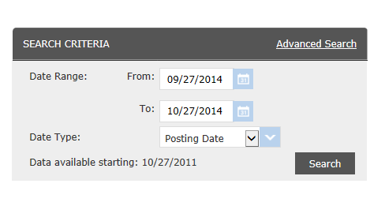

* Select the small box under “Additional Information” to upload the receipt. Use MapQuest with mileage details when requesting mileage reimbursement.
* Click on the check box under “Reviewed”
* Select “Save”
* Notify approver via e-mail that your transactions are ready for approval

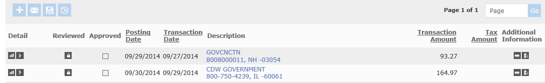

* Notify your approver that your transactions are ready for approval either using the smartdata system or your regular e-mail.
* Reimbursements must be approved by Wednesday in order to have a check available for pick up on Friday.
* Any checks not picked up by Tuesday of the following week will be mailed to the home address on file.