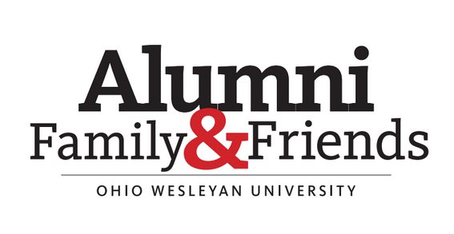
Greetings from your Alumni Board of Directors! On behalf of the Alumni Board we would like to thank the alumni for all you do to support the University with your time, talent and treasure.

In support of your efforts, the Alumni Board gathered on campus during Homecoming weekend for one of our biannual meetings to discuss, develop and strengthen initiatives to support University goals, and to foster alumni engagement. While on campus we had the opportunity to engage students, staff and other alumni who were on campus for Homecoming. Some of the highlights of our weekend include:

Emerging Leaders Reception: On Thursday night, the Student Alumni Relations Committee of the Alumni Board hosted a reception for over eighty current students. The students in attendance were identified by faculty, counselors, coaches and other members of the University staff as engaged and thoughtful leaders in their classes, teams, clubs and groups. The Emerging Leaders Reception provided opportunity to these students to meet and network with current Alumni Board members. Those in attendance participated in group activities that identified common interests to facilitate conversation and create bonds. Students and Alumni Board members were encouraged to exchange contact information to continue communicating outside of the reception and throughout their journey as students at OWU.

The Emerging Leaders program is an initiative the Alumni Board is proud of, one that continues to grow, and a program that has even led to identification of students who are likely to be good candidates to join the Alumni Board sometime after they graduate! There are multiple members of the current Alumni Board who attended at least one Emerging Leaders when they were students at OWU!

Board Meeting: On Friday the Alumni Board convened in full for its biannual meeting. The Board was treated to a presentation about the Bishop Elevate program by Thea Smekens, director of first-generation student success. The Bishop Elevate program provides tailored programs and experiences for first-generation college students. The Board got to listen about the program’s achievements and challenges, and discuss ways the Alumni Board can become directly involved in the Bishop Elevate program to make it even more of a success. You can learn more about Bishop Elevate and the work Thea is doing by attending this event during First Generation Awareness week in November.

The Board was also provided its first opportunity to meet in person with new Vice President of Enrollment, Adam Smith. Adam provided the Board with information regarding nationwide and regional trends in college enrollment, the effects of those trends on Ohio Wesleyan’s efforts to recruit new students, and up to date information on recruiting efforts for next year’s incoming class. Adam engaged the Board in a discussion of its role in supporting new student recruitment, how the Board can become even more directly involved, and how we can engage alumni in the regions and communities we live in to identify and recruit high school students to consider OWU.

An example of just one program the Board supports is the Alumni Referral Program which provides a $4,000 award ($1,000 per year) to incoming students who are recommended and referred by alumni. Referring is easy and can be done online at Alumni Student Referral | Ohio Wesleyan University (owu.edu) See how I did that!? I just supported the university by promoting the alumni referral award in this message. You can too by referring high school and other college eligible students of family, friends, and neighbors, coworkers, etc. to Ohio Wesleyan and filling out the Alumni Student Referral online form on their behalf!

Finally, the Alumni Board was very happy to meet Ohio Wesleyan’s 17th president, Matt vandenBerg. In what was no doubt a very busy first Homecoming week on campus for OWU’s newest leader, President vandenBerg carved out considerable time for the Alumni Board and we are grateful. President vandenBerg has made (and continues to make) considerable efforts to meet with as many student, faculty, staff, alumni and community groups as possible in his first months on campus to learn and understand about the University, the community in which it thrives, and the challenges it faces moving forward. President vandenBerg shared some of what he has learned from those meetings with the Alumni Board, outlined goals he has for identifying strategic initiatives for the University to set itself apart in a crowded college landscape, and engaged the Alumni Board in discussions on how it may further his vision for the University. The Alumni Board was grateful for the President’s time and looks forward to continuing its support of the University during his tenure.

Homecoming!: Maybe, the best part of the weekend for the Alumni Board was the opportunity to attend the many scheduled Homecoming events and activities taking place while the Board was on campus. These include, but are not limited to, BishopFest, Athletics Hall of Fame induction, Football and Soccer tailgates, Black Alumni Network Meet & Greet and the Gospel Lyres 50th Anniversary Concert, and various Fraternity gatherings. The weather cooperated and it was a perfect fall weekend in Ohio for Homecoming. The Alumni Board would like to thank the entire staff at Ohio Wesleyan for putting such effort into a wonderful Homecoming weekend! These weekends, which are full of spirit and community, remind you just how special Ohio Wesleyan is. As you see opportunities to attend OWU events in your community, attend. As you see opportunities to volunteer and get involved, say yes to volunteering (owu.edu/volunteer).

Your Alumni Board is here to represent you, our dedicated and passionate alumni. Please don’t hesitate to contact me with any questions or concerns at any time. It’s an honor to serve you and Ohio Wesleyan.

Sincerely,
Keith Rozanski
President, Alumni Board of Directors

